SIMATS ENGINEERING
JAVA PROGRAMMING
LEVEL 1 EXAM
Name : Subiksha U
Reg no : 192424135

1.
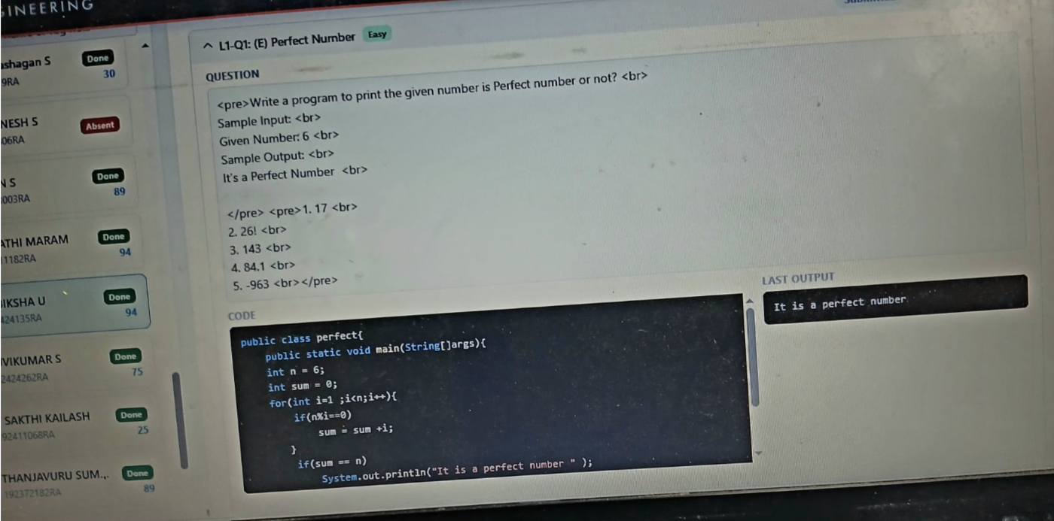

2.
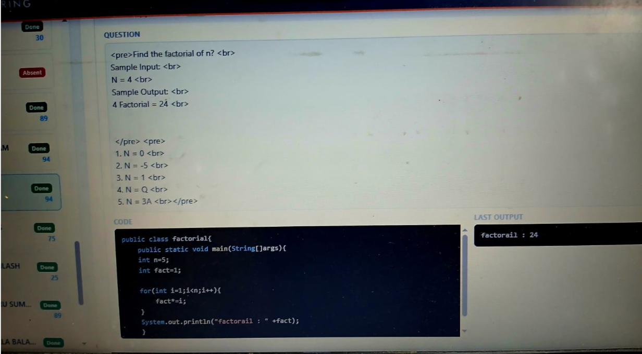
3.
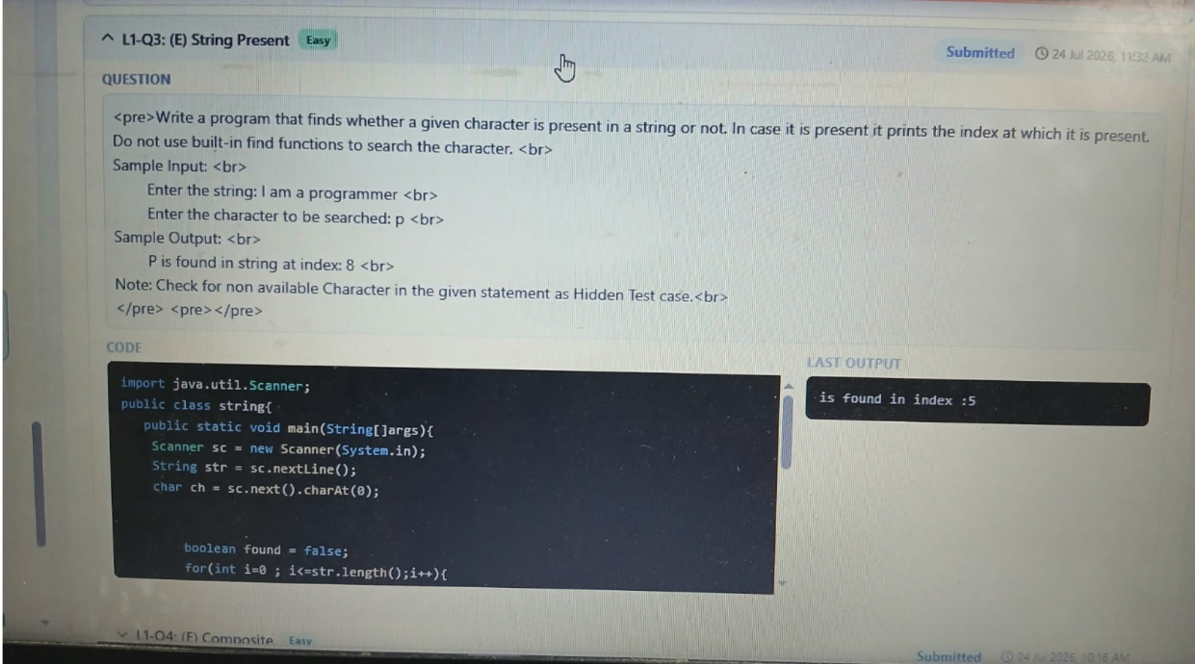

4.
